7th July 2024

**GENERAL MANAGER**

Wingecarribee Shire Council

PO Box 141

MOSS VALE NSW 2577

Attn: Mr. Hugh Halliwell

**RE: REQUEST FOR FURTHER INFORMATION FOR PROPOSED**

**NEW RESIDENTIAL FLAT BUILDING CONTAINING AFFORDABLE HOUSING APARTMENTS AT 1-5 RAINBOW ROAD, MITTAGONG NSW**

**Lot 32, DP 9299 & Lots 141-142, DP 531051**

**Council Reference: LUA 23/1070**

On Wednesday the 5th June 2024 the Southern Regional Planning Panel met at 9.00am to further discuss the above mentioned development, following the briefing meeting the following additional information was requested.

A brief summary of the Registered Housing Provider is included to provide background on the operation goals of the organisation.

**Item 1: Hydrological Concerns**

Our Geo-Hydrologist has been able to provide proven methods to mitigate the effects of unexpected hydrological conditions that maybe met during excavation. The Geo-Hydrologist has not completed due to an urgent matter with the EPA, the consultant has advised that it will be finished by Tuesday next week. We apologise for this delay.

**Item 2: Arborist Report**

The Arboricultural Impact Assessment authored by “Truth About Trees” dated 12th July 2024 has been amended to clearly identify the trees that will be removed and tress to be retained, a summary of the statistics from page 17 are as follows;

76 trees have been assessed the majority are within the property with adjoining trees adjacent to the site boundary also being included in the assessment. The trees are not included to increase the amount of trees to retained following the development but rather to ensure that their health is considered as part of the development. It is not our intention to “borrow” these trees for the development, it is however noted that the trees in the adjacent Council land do provide soften the built form of our development. It is our intention to request Council for permission to carry out minor works to improve the condition of these trees by removing noxious and invasive woody weeds from the under storey and ivy growing to a trunk height of over 60%. Please see pictures below.

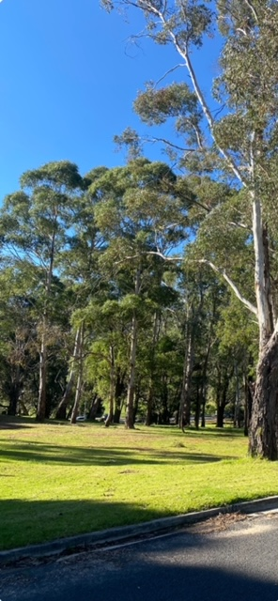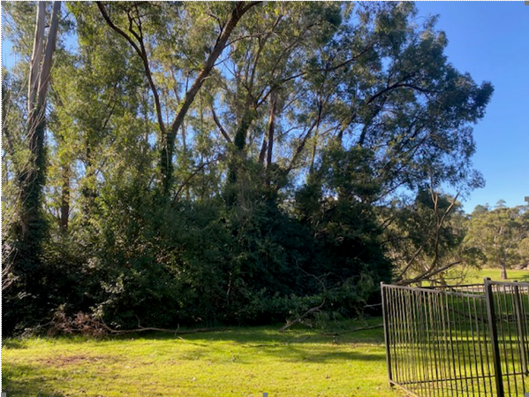  
*Note the significant difference between the two stands of trees. The stand adjacent to our property (LHS picture) is overgrown and it is our intention with Council’s consent is to improve the health of the tree and the under storey as per the stand of trees on the eastern side of the adjacent park (RHS picture).*

In summary there are three main points from the report,

**76 trees were surveyed.**

**24 trees will be retained** and protected throughout the development. Improvement to building setbacks have increased areas of deep soil zones have space to minimise the impact for existing trees and created additional space for new planting.

**5 trees will be removed** due to their potentially hazardous defects and structural condition.

**47 trees will be removed** to enable the development to proceed in its current form. This includes 3 trees located on the northeastern adjoining property (180 Old Hume Highway Mittagong) owners consent has been granted to remove the trees and create a stormwater easement.

**Tree Growth:**

The species of eucalypt tree selected is defined in the report, the tree will be advanced with a size equivalent to100litre pot and be approximately 3 to 4 metres when planted. At this size it is expected to grow vigorously with a yearly growth rate of 1.0 metre.

**Item 3: Transport and Car Parking**

The traffic report has been reviewed by our consultants Transport and Traffic Planning Associates Dated June 2024 Version G.

Again there are three main numbers;

**Car Parking available:**

73 Spaces are available including;

9 Shared spaces

9 Visitors spaces

**SEPP Requirement:**

The SEPP requires the provision of 26 car spaces.

**DCP Requirement:**

The Mittagong DCP requires the provision of 72 car spaces.

The justification for providing the additional care spaces is as follows,

Most Tenants from the affordable rental apartments will be new immigrants to the country who have secured a regional visa. Regional visas are used by the department of immigration to support rural and regional communities with access to a quality workforce as many Australian Nationals leave these communities looking for opportunities in the main cities making it increasingly difficult to find staff for the service and manual trade industries. Our current tennants predominantly work in hospitality, retail, trades such as mechanical services and a very high percentage in Healthcare both Acute and Aged care.

Many of the fields of employment require shift work or have unusual working patterns. Examples of these are health staff who work a rotational 3 shits per day roster and hospitality staff that work into the evening in local clubs and restaurants.

The Southern highlands does have an existing public transport network but it based on a traditional work pattern and school pick up times. It provides connections for the community to fit a 9 to 5 job plus the standard “school runs”. Even through these peak times the utilisation of the transport is quite low and it is uneconomical for the private operators to provide further services. It can be seen from the bus timetables that there are no bus services available on a Sunday.

An advantage for the Rainbow Road site is that it is located 1.2km from the Mittagong Railway Station being a 15 min walk. Therefore, even though there maybe limited bus services the train station is relatively close being a 15 minute walk. A further advantage is that the site is a 5 minute walk to the Mittagong Public School, Mittagong Town Centre, Mittagong bus interchange and bulky goods outlets.

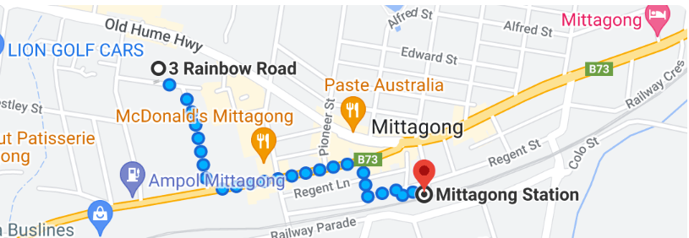

The concept for providing the additional car parking even though the site is well located for day to day requirements in daily supplies is due to the need to have independent transport for work, specifically shift work. It is noted that tenants do carpool to improve efficiency of transport and reduce transportation costs but fundamentally there are few bus services at 11.30 pm on a Sunday night or 5.30 am Monday morning. It is on this basis that we want to provide a car space for each apartment to ensure that residents do not resort to on-street parking and negatively impact street amenity.

A note worthy observation is the financial journey of the cohort of immigrant communities, the capacity to own a new car is one of the early signs of growing financial prosperity. Our current affordable housing project has many new Mitsubishi / Kia etc SUV’s and the like, very few luxury brands but entry price new vehicles.

**Item 4: Waste Management:**

The concepts of waste management were detailed in the Waste Management report prepared by lid, Low Impact Development Consulting dated the 27/09/2022. As detailed in this initial report waste removal will be as follows;

1. Tenants will collect and sort waste in their apartments and then take it down to the basement to place in the appropriate colour waste receptacle.

2. Maintenance staff will then co-ordinate with the waste collection contractor to have the bins at the kerb side ready for the bulk waste removal truck. The general waste will be picked up by a front lift truck. The truck will park parallel to the kerb enabling vehicles to safety pass in the remaining lane. This section of Rainbow Road is straight and flat providing a safe line of sight for vehicles to pass safety.

Specialised waste such as garden waste, soft plastic and E-waste will be picked up by side lift bins on as needs basis. It can be noted that the bulk of green waste will be removed by employed or contracted gardening staff.

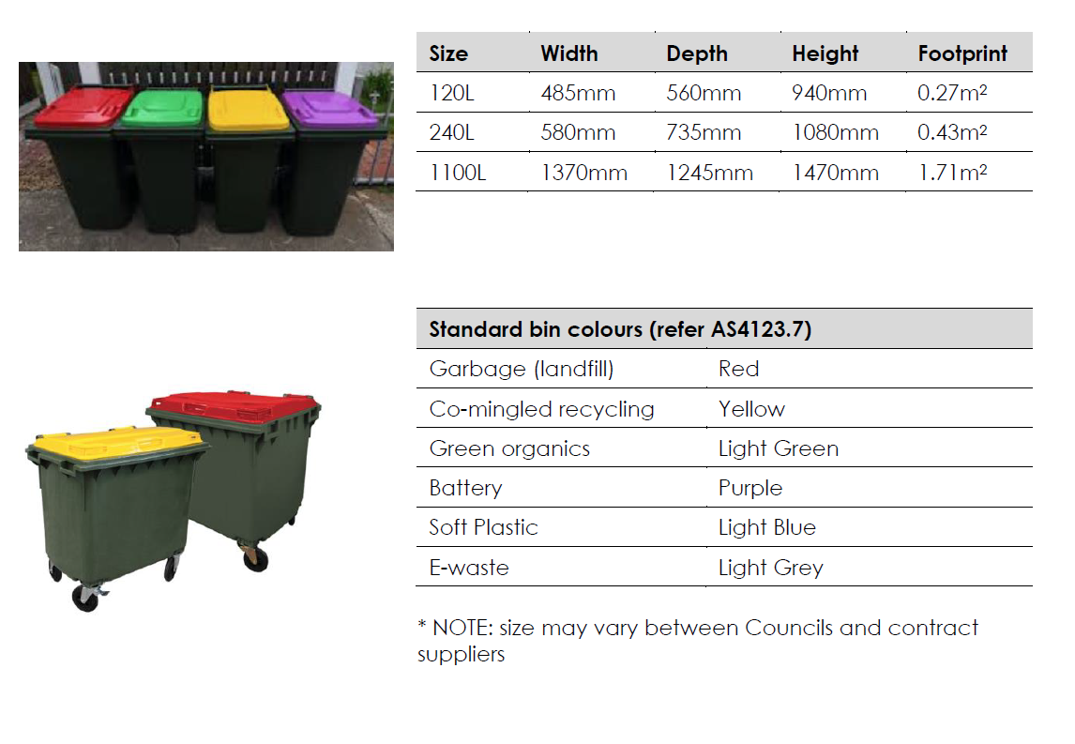

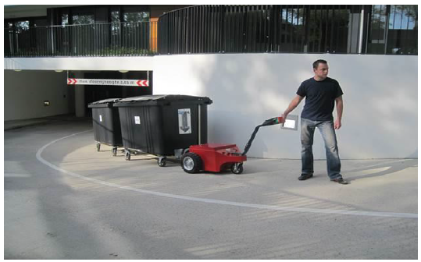

**Registered Housing Provider**

**This supplementary information is included again to provide background on the Registered Housing Provider.**

The Blissett Group has operated in the Southern Highlands for over 23 years and has developed many community assets such as retirement villages, residential aged care facilities and supported living communities. During this process it became obvious that a form of affordable rental accommodation was necessary for the workforce and hence the creation of Robsea Nominees Pty Ltd atf TBG Affordable rental Trust. The Registered Housing Provider is a tier three provider which means that the provider does not own property in its own right but rather manages the property on the behalf of others.

TBG Affordable Rental Trust has been registered since 2016 and has maintained its registration by successfully passing its accreditation process as required every second year. Currently TBG Affordable Rental Trust manages 23 apartments at 200 Old Hume Highway Mittagong.

TBG Affordable Housing Trust is the applicant in this development which is consistent with its Strategic Plan to increase the number of apartments under its management to strengthen the organisations sustainability. In the development at 1 – 5 Rainbow Road 50% of the apartments have a statuary requirement to be managed by a Registered Housing provider but in the case of the development 100% of the apartments will be managed by the Registered Housing provider.

**Target Tenants**

TBG Affordable Housing Trust targets the “working poor” small families or new immigrants to the highlands where the main income is derived from entry level service employment, examples of this are cooks and kitchen hands, retail assistants and unskilled health workers. The highlands core population has 3 times the average number of persons over the age of 60 and therefore requires a significant number of younger community members to help provide service to this older demographic. The younger workers are new to the area typically being new immigrants to Australia from areas such as Nepal, Philippines, China and other like nations. New arrivals are then met with the highlands high real estate prices and therefore initial home ownership can be difficult and available rental properties can have high weekly rental amounts. TBG Affordable Housing Trust focuses on this group’s housing needs in conjunction with local property developers to ensure that quality, clean and well maintained rental properties are available at an affordable amount. Over the 6 years that TBG Affordable Rental Trust has been providing this accommodation we have seen many families come to the highlands and then establish themselves to the state that they can then make their own purchase into the local property market. This provides incredible stability to these families, a stable workforce of committed employees and a vibrant, cultural diverse community.

The development at 1 – 5 Rainbow Road allows this process to continue where not only quality accommodation is provided but rent is set at a level that enables saving to be made and communities to be developed to then grow the financial independence of the tenants. A very positive and sustainable cycle.